Atlas Streaming Service

Introduction

The purpose of this document is to provide an overview of the architecture and design of a quoting and RFQ auto reply strategy in C#. The application is designed to manage a set of instruments in real-time, utilizing market data to generate and update quotes for the instruments, and handling incoming RFQ’s from clients.
The application is structured around several key components, including microservices responsible for managing various aspects of the system, such as the RFQService, PricingService, and DataFeedService, AxesService and AssetsMonitor service and classes such as the StreamStrategy and MultiStreamingStrategy that are responsible for managing individual financial instruments and coordinating multiple strategies, respectively. In addition, the application includes several utility classes, such as the RFQValidator, Logger, and the MarketData that support the operation of the system.

Microservices are a software development approach that emphasizes the decomposition of a large, monolithic application into smaller, loosely-coupled services. Each service typically performs a single, well-defined function, such as handling authentication, processing payments, or managing inventory. Services communicate with each other through APIs, and can be developed and deployed independently of each other. This approach has several advantages, including improved scalability, resilience, and agility, as well as better alignment with modern software development practices such as DevOps and continuous delivery. However, microservices also introduce additional complexity, as developers must design and manage a distributed system composed of multiple services, each with its own unique requirements and dependencies. Despite these challenges, microservices have become increasingly popular in recent years, particularly in the context of cloud-native application development.

The architecture of the application is designed to be modular and scalable, allowing for easy addition of new financial instruments and services as needed. The application is designed to be flexible and adaptable, allowing it to handle changes in market conditions and respond to new opportunities as they arise.

Overall, the application is designed to provide a robust and reliable platform for managing and quoting financial instruments in real-time, utilizing the latest technologies and best practices to ensure high performance and maintainability.

System Architecture

The trading application is designed using a modular and scalable architecture that allows for easy addition of new financial instruments and services as needed. The application is structured around several key components that work together to manage and quote financial instruments in real-time.

The main components of the system include the services responsible for managing various aspects of the system, such as the RFQService, PricingService, DataFeedService, LambdaAxesService, and AssetMonitorService. These services are responsible for handling specific tasks and coordinating with other components as needed to ensure the smooth operation of the system.

In addition, the system includes classes such as the StreamingStrategyBase and MultiStreamingStrategy that are responsible for managing individual financial instruments and coordinating multiple strategies, respectively. These classes utilize the services to generate and update prices for the instruments, and handle incoming RFQs from clients.

The system also includes several utility classes, such as the RFQValidator and Logger, that support the operation of the system. These classes provide additional functionality and support to the other components in the system, helping to ensure their reliability and performance.

Overall, the architecture of the trading application is designed to be flexible, scalable, and modular, allowing it to handle changes in market conditions and respond to new trading opportunities as they arise. The various components work together seamlessly to ensure the smooth and efficient operation of the system, enabling traders to manage and quote financial instruments in real-time.

The system architecture of our trading application is illustrated in the diagram below. This diagram provides a high-level overview of the different components of the system and their interactions, and is intended to help readers understand how the system functions and how data flows through the system. The diagram shows the main services used by the system, such as the PricingService, RFQService, and DataFeedService, as well as the StreamingStrategyBase and MultiStreamingStrategy classes that handle the actual pricing and trading of financial instruments.
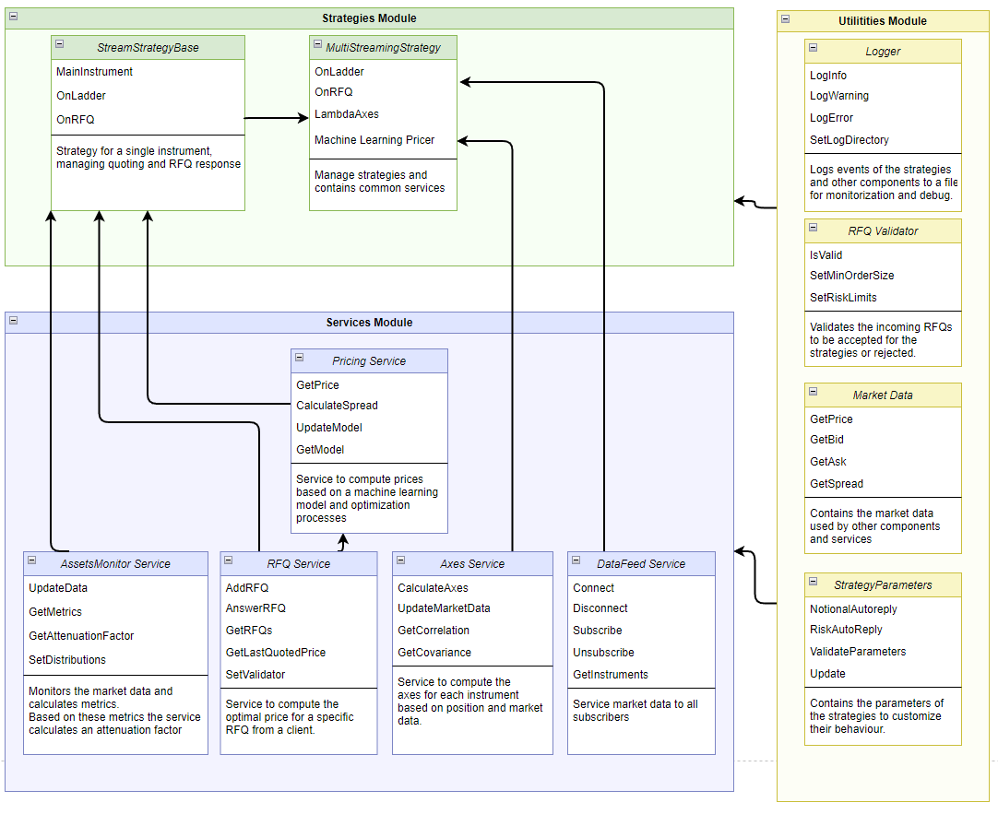

Services
The trading application is built around several key services that are responsible for managing various aspects of the system. These services work together to ensure the smooth and efficient operation.

RFQService
The RFQService is responsible for receiving and processing incoming RFQs from clients. When an RFQ is received, the service validates the request using the RFQValidator utility class, generates a price for the requested instrument using the PricingService, and sends the price back to the client. The RFQService is also responsible for keeping track of the last price answered, which can be accessed by other components in the system as needed.

PricingService
The PricingService is responsible for generating and updating prices for financial instruments in real-time. The service utilizes a machine learning model to calculate prices based on market data received from the DataFeedService, and provides these prices to the RFQService and StreamingStrategyBase classes as needed.

DataFeedService
The DataFeedService is responsible for receiving and processing market data from external sources, such as exchanges and financial data providers. The service collects and aggregates data on various financial instruments and provides this data to the PricingService and other components in the system as needed.

LambdaAxesService
The LambdaAxesService is responsible for calculating the appropriate axes for each instrument in the system based on their positions and prices. The service utilizes various algorithms and formulas to calculate the optimal axes for each instrument, and provides these values to the StreamingStrategyBase classes and the PricingService as needed.

AssetMonitorService
The AssetMonitorService is responsible for monitoring various metrics for each financial instrument in the system, such as spread volatility and liquidity, and using this data to generate an attenuation factor that can be used to adjust the spread of quoted prices by other components. The service provides this factor to the StreamingStrategyBase classes and PricingService as needed.

These services work together to ensure the smooth and efficient operation of the system, enabling traders to manage and quote financial instruments in real-time with ease.

Strategies
The trading application utilizes two main strategies for managing financial instruments: the StreamingStrategyBase and MultiStreamingStrategy classes. These classes work together to generate and update prices for financial instruments, and handle incoming RFQs from clients.

StreamingStrategyBase
The StreamingStrategyBase class is responsible for managing individual financial instruments in the system. When a new instrument is added to the system, an instance of the StreamingStrategyBase class is created to manage that instrument. The class receives market data from the DataFeedService and utilizes the PricingService to generate and update prices for the instrument. The class also answers incoming RFQs from clients, validating the requests using the RFQValidator utility class and generating prices using the PricingService. When a client sends an RFQ, this strategy makes use of the RFQService to create a specific price for the client.

MultiStreamingStrategy
The MultiStreamingStrategy class is responsible for coordinating multiple StreamingStrategyBase classes in the system. The class receives RFQs from clients and routes them to the appropriate StreamingStrategyBase instance based on the requested instrument. The class also manages the quoted prices for multiple instruments, utilizing the LambdaAxesService to calculate the appropriate axes for each instrument.

In general, a microservice architecture favors breaking down an application into small, independent services that can be developed, deployed, and scaled independently.

In the case of StreamingStrategyBase and MultiStreamingStrategy, if they are designed to be standalone components that can be deployed and scaled independently from the rest of the application, they could be considered microservices. However, if they are tightly coupled to other components and cannot be easily separated, they may be better classified as services within a monolithic architecture.

Ultimately, whether or not you choose to treat StreamingStrategyBase and MultiStreamingStrategy as microservices depends on your specific requirements and the architectural goals of your application.

Utilities
The trading application utilizes several utility classes to support the operation of the system. These classes provide additional functionality and support to the other components in the system, helping to ensure their reliability and performance.

RFQValidator
The RFQValidator utility class is responsible for validating incoming RFQs from clients. The class checks the validity of the requested instrument, the requested quantity, and the requested risk, and returns an error message to the client if the request is invalid.

Logger
The Logger utility class is responsible for logging system events and errors. The class logs various events, such as incoming RFQs, generated prices, and system errors, to a log file for later analysis and debugging.

StrategyParameters
The StrategyParameters class is a utility class that provides traders with a way to adjust the behavior of the StreamingStrategyBase and MultiStreamingStrategy classes to suit their specific needs. This class contains properties or fields for various parameters, such as sensitivity, order sizes to accept and auto reply, axes configuration, aggressiveness of the algorithm etc, which traders can adjust as needed to customize the behavior of the strategies. The StrategyParameters class is designed to be easily extensible, allowing new parameters to be added as needed to accommodate future needs.

Application Flow
The application flow of the trading application is designed to be flexible, scalable, and efficient, here is a brief summary of the flow step by step:

- Market data updates are received by the DataFeedService from the brokers. These updates include information about the current state of the market, such as bid/ask prices, trading volumes, and order book depth.
- The DataFeedService publishes the market data updates to a RabbitMQ queue, which acts as a message broker. The queue is configured to distribute the messages to the appropriate subscribers based on the message content or routing key.
- The StreamingStrategyBase classes are subscribed to the RabbitMQ queue, and receive the market data updates as messages. When a message is received, the OnLadder method of the strategy is called, which processes the market data and calculates the new bid/ask prices for the instrument.
- The StreamingStrategyBase class calls the PricingService to obtain the new bid/ask prices for the instrument. The PricingService is responsible for managing the machine learning models and other pricing algorithms that are used to generate the quotes. It may also use data from other sources, such as the order book, liquidity metrics, or market trends, to calculate the optimal prices.
- Once the new bid/ask prices are obtained, the StreamingStrategyBase class publishes them to the market, using a protocol such as FIX or proprietary API. This allows the clients to see the updated prices and place orders accordingly.
- When a client submits an RFQ petition, it is received via the RabbitMQ queue by the corresponding StreamingStrategyBase class, which calls the RFQService, this service validates the request by using the RFQValidator and generates a quote based on the current market conditions. The RFQService may use the same pricing algorithms and models as the StreamingStrategyBase class, or it may use different ones depending on the type of RFQ or client request.
- Once the quote is generated, the RFQService publishes it to the market, using the same protocol as the StreamingStrategyBase class. The client receives the quote and can decide whether to accept it or not.
- The AxesService is responsible for calculating the appropriate position or risk management strategies for each instrument based on the current market conditions and trading activity. It may use data from the order book, liquidity metrics, and historical trends to make these calculations. It is subscribed to the updates in position of the DataFeedService. Once an update of the positions of the instruments is received by this service, a new set of axes is generated and sent to each StreamingStrategyBase.
- The AssetMonitor service monitors the market conditions and metrics for each instrument, such as spread volatility and liquidity, and generates an attenuation factor to increase or decrease the spread of the quoted prices. This allows the system to adjust to changing market conditions and provide competitive quotes to the clients. The asset monitor is also subscribed to the DataFeedService and makes constant adjustments to the attenuation factor of every instrument, which can later be requested by the StreamingStrategyBase class or the PricingService as needed.

C# Frameworks for Microservices Development
When it comes to developing microservices in C#, there are several frameworks available that can help you build powerful and scalable microservices-based applications. These frameworks provide a range of features and capabilities for building distributed systems, such as message-based communication, service discovery, and fault tolerance.

.NET Core: This is a cross-platform, open-source framework that provides a robust set of tools and libraries for building microservices. .NET Core includes features such as dependency injection, built-in support for configuration management, and a powerful development environment with Visual Studio or Visual Studio Code.

ASP.NET Core: This is a web framework built on top of .NET Core that provides a powerful set of tools for building web-based microservices. ASP.NET Core includes features such as routing, model binding, and middleware support, and integrates with other Microsoft technologies such as Azure cloud services and Visual Studio development environment.

Service Fabric: This is a distributed systems platform developed by Microsoft that provides a rich set of tools and services for building and managing microservices. Service Fabric includes features such as automatic scaling, fault tolerance, and service discovery, and can be deployed on-premises or in the cloud.

Nancy: This is a lightweight, open-source framework for building web-based microservices in C#. Nancy emphasizes simplicity and flexibility, and includes features such as routing, model binding, and error handling.

MassTransit: This is an open-source framework for building distributed applications in C#. MassTransit provides a powerful set of tools for building message-based systems, including support for message routing, serialization, and durable messaging.

Akka.NET: This is a .NET implementation of the Akka toolkit, a powerful and popular framework for building concurrent and distributed systems. Akka.NET provides features such as actor-based concurrency, distributed messaging, and fault tolerance, and can be used to build highly scalable microservices.

Steeltoe: This is an open-source framework for building microservices on top of .NET and .NET Core. Steeltoe includes features such as service discovery, configuration management, and distributed tracing, and can be used to build cloud-native microservices on platforms such as Kubernetes and Cloud Foundry.

Choosing the right framework for a microservices-based application will depend on a variety of factors, including the team's experience and expertise, the specific requirements of the application, and the constraints of your environment. It's important to evaluate the available options and choose the framework that best meets the needs of our project.

Performance and Scalability
The trading application is designed to be highly performant and scalable, allowing it to handle a large volume of market data and client requests with minimal latency and downtime.

The application utilizes various performance optimization techniques, such as multithreading, asynchronous programming, and caching, to ensure that it can handle a large number of requests in real-time. The use of these techniques also helps to minimize latency and reduce the risk of system downtime.

In addition, the application is designed to be easily scalable, allowing it to handle an increasing volume of requests as the system grows. This is achieved through the use of modular components that can be easily added or removed from the system as needed, as well as the use of load balancing and other scalability techniques.

For example, using a message queue can be a more scalable and reliable solution for publishing market data updates to multiple subscribers. By using a message queue, the DataFeedService can simply publish market data to the queue, and each StreamingStrategyBase instance can subscribe to the queue and receive updates as they are published. This allows for better decoupling between the DataFeedService and the StreamingStrategyBase instances, and can handle high volume of market data updates more efficiently.

There are several message queue systems available that you can use to implement a message queue for your project. Here are some popular options:

RabbitMQ: RabbitMQ is a mature and widely-used open source message broker that supports multiple messaging protocols and features such as message routing, priority queues, and message acknowledgements. It is written in Erlang and has client libraries for many programming languages.

Apache Kafka: Apache Kafka is a distributed streaming platform that can handle high volume of data streams and supports real-time data processing, message replay, and fault tolerance. It is often used for use cases such as log aggregation, event processing, and data ingestion.

AWS SQS: Amazon Simple Queue Service (SQS) is a fully-managed message queue service provided by Amazon Web Services (AWS). It is highly scalable and reliable, and can be integrated with other AWS services such as Lambda and EC2. It supports both standard and FIFO (first-in, first-out) queues.

Microsoft Azure Service Bus: Azure Service Bus is a fully-managed message queue service provided by Microsoft Azure. It supports advanced messaging features such as message ordering, transactions, and duplicate detection, and can integrate with other Azure services such as Functions and Logic Apps.

The best system to use for your project will depend on your specific requirements, such as performance, scalability, reliability, and integration with other systems.

The DataFeedService could also publish RFQ petitions to a message queue, which can then be consumed by the appropriate services or microservices, such as the RFQService or the StreamingStrategyBase classes.

Publishing the RFQ petitions to a message queue would decouple the RFQ generation from the RFQ processing, which can improve the overall system performance and scalability. It would also enable the RFQ petitions to be processed asynchronously and in parallel, which can further enhance the system's throughput and response time.

By using a message queue, the RFQ petitions can be reliably and efficiently transmitted between different services or microservices, even if they are running on different machines or in different regions. This can ensure that the RFQ processing is scalable, fault-tolerant, and resilient to failures or network disruptions.

Regarding the publishing of prices and RFQ responses to the market, one possible approach is to have the StreamingStrategyBase classes publish the new quotes directly to the market, using a protocol such as FIX or proprietary API. This would allow for fast and efficient quote publication, but it may also increase the load on the system and require more resources, because each instance of the class would need to establish and maintain a connection to the market, and handle the sending of quotes. This could create a significant load on the system if there are many instances of the class or if the volume of quotes is high.

Another approach is to use a separate microservice or component to handle the publishing of quotes to the market. This could help to distribute the load and provide a centralized point for monitoring and control. The StreamingStrategyBase classes would then send the new quotes to this service, which would be responsible for publishing them to the market using the appropriate protocol. This
would allow for more efficient use of resources, since this component could manage the connections to the market and optimize the quote sending process. It would also provide a single point of control and monitoring, which could be beneficial for managing the overall system

Future Work
While the trading application is currently fully functional and meets the needs of our traders, there is always room for improvement and enhancement. Some areas of future work and improvement include:

Further optimization of the pricing algorithms used by the PricingService and StreamingStrategyBase classes, to ensure the most accurate and reliable prices for financial instruments.
Enhanced monitoring and reporting capabilities for the AssetMonitor service, to enable traders to better track and manage their risk exposure.

Additional support for different types of financial instruments, such as credit bonds and swaps, to enable traders to manage a wider range of instruments in the system.

Integration with additional external data sources, such as news feeds and sentiment analysis tools, to provide traders with additional insights into market trends and fluctuations.

Conclusion
The trading application is a powerful and flexible platform that enables traders to manage and trade financial instruments in real-time. The system is designed to be highly performant and scalable, enabling it to handle a large volume of market data and client requests with minimal latency and downtime.

The application utilizes a modular architecture, with separate services for managing different aspects of the system, and a set of utility classes that provide additional functionality and support. This design helps to ensure the reliability, performance, and scalability of the system, while also enabling easy maintenance and updates.

Overall, the trading application is a powerful and effective tool for managing and trading financial instruments in real-time, and is well-positioned to meet the needs of traders in today's fast-paced and complex financial markets.

